Please mail this form and a check, made out to LANA, so that they arrive by
April 21, 2025
to:
Joy Pedroni
3966 Estate Drive
Vacaville, CA 95688

Kids & Camelids  April 26, 2025  Show Fee Summary | 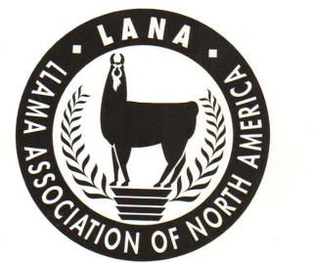

Youth Handler’s Name:

Youth Handler’s Address:

Parent’s email: Parent’s phone number:

Youth Handler’s Parents’ Names:

Ranch Name or 4H/FFA Youth Group Name:
Handler’s  Birthdate | As of Jan. 1, 2024  Sub Junior (<7)  Junior (7-11)  Intermediate (12-14)  Senior (15-19) | Youth Handler‘s age category (Circle one) | Please indicate if the youth handler plans to bring a “friend” to the show to try out an obstacle course.  □ Yes □ No
Sub junior Junior
Intermediate Senior

Llama’s or Alpaca’s Name | Breed (Circle one) |  | Youth Registration Fees:  LANA youth members*: $30  Nonmembers: $40 |  | Total fees:
 | Llama Alpaca
*LANA Members may be either individual, ranch or youth club members
All Entrants must read and sign: It is understood and agreed that LANA and the owners of Mares’ Nest/Lamarah Ranch and their officials, employees and agents shall not be responsible for any loss, damage, or injury to any person, property or animal which is caused directly or indirectly for any reason. The undersigned also agrees to hold harmless LANA and the owners of Mares’ Nest/Lamarah Ranch for any expense or liabilities, including attorney’s fees.
Parent’s Signature: _______________________________________________________________________ Date: ____________________________________

